Hill School, Eldoret Picnic in the Park, Sydney
23 February 2003

My thanks to Steve Le Feuvre for publicising this event and offering to host the report on his Web site. And as this is an Old Cambrians site, three members of the group below completed their secondary education at the Prince of Wales School: Brian Turner (Nicholson/Scott ’47-’50); Ben Christie (Grigg ’51-’54) and Roy Cordell (Clive ’56-’59).
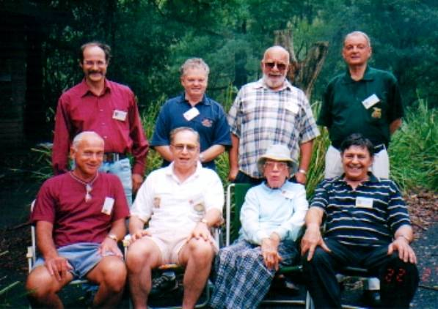
Standing from left-right: Neils Langevad (55-60); Andy Vesey-Wells (50-56); Roy Cordell (52-55); Brian Turner (44-45).
Sitting: George Chamberlain (nee van Rooyen) (59-62); Dave Lichtenstein (50-56); June Parker (Staff) (52-60); Ben Christie (47-50).

The above Sydney-based Hill School Hooligans and their memsahibs recently held a picnic at Sydney’s Lane Cove River National Park. The occasion was the flying visit to Sydney from South Africa by much loved and respected former School teacher, June Parker to catch up with her niece. (Of wider interest is that June also taught at Nairobi Primary School prior to the Hill School and at Muthaiga Primary School after the Hill School.)

Despite the short notice and the dramatic change of the weather associated with the breaking of the drought, we managed to get a good half of the Sydney-based Hill School folk to attend although it was never intended to be a numbers game. Indeed this small select group was able to get to know each other very well during the course of the day, starting with school reminiscences and picking up with more eclectic topics such as international politics and TV soap operas (so that non-Hills or “rafikis” could join in as well).

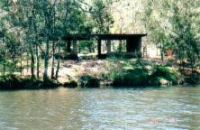 | 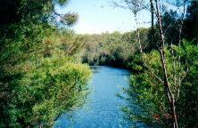
We had to the venue totally to ourselves – the shed by the waters edge dubbed the Uasin Gishu Hall by Roy Cordell (because of previous Hill School and All East African Schools reunions held here) and by extension the nearby Lane Cove River became the Sosiani River.
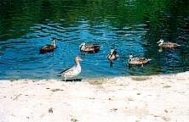 | 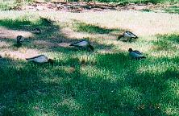
Our only visitors were of the scaly and furry kind. In fact not only were there ducks at our feet but we also had duck on the table (with some concern about mad duck’s disease ☺). On the other hand, Ben Christie decided to barbeque some nyama but did not reckon with one of the local kookaburras taking a shine to one of his steaks while he was still barbequing it and flying off with it!

I trust that the above photos and stories gives you a bit of a glimpse of the day’s events which was thoroughly enjoyed by all.

We will have another All East African School’s picnic at the same venue on Sunday 19 October and this will be preceded by a Kenya Regiment Association curry do on Saturday 18 October which is being organised by Brian Turner. The timing will coincide with the start of the Rugby World Cup. For further details on both events please contact me on ‘lichtend@ozemail.com.au’ and of course that also applies to any fellow Hill Schoolians that I have not yet been in touch with.

My thanks to all who attended the picnic and my salaams to all Hill Schoolians and other East Africans around the globe.

Dave Lichtenstein

